Homework 2 (2014)
Title : Moving Robot
Due Date: Week 12 (during practical class)

Description :
In this homework, you are required to create a moving robot. One interface called MyRobot is provided and you should implements this interface in your application.

public interface MyRobot
{
public void draw(Graphics2D g2);
public void move();
}

In this homework, you should create a Frame which contains THREE radio button which representing THREE different colors. Besides that, you should have also create a ComboBox which contains at least 3 different shapes. And finally a button with caption “Move my Robot”. Sample application shows as below:
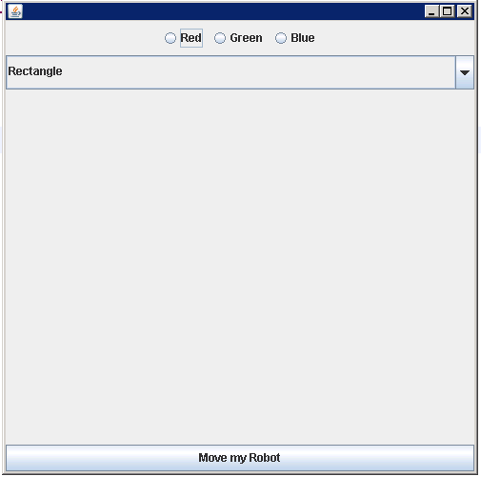

User should able to create their desired robot by choosing the color and the shapes. User can draw the shapes through using the mousepressed and mousereleased event. For example:
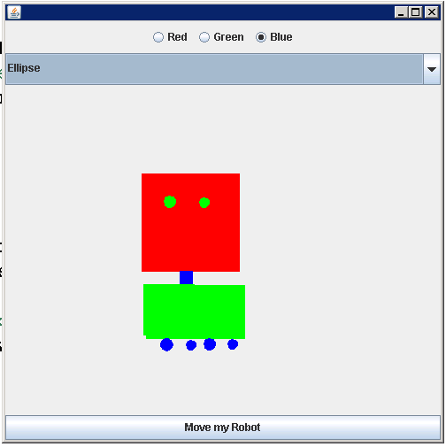

Sample output

After the robot is created, you can move the robot by just clicking on the move button. And the robot will move towards the right hand side.
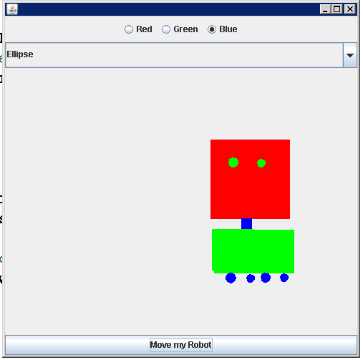

Requirements
- Must have Tester program
- Must implements the MyRobot interface
- Must have at least 3 types of shapes
- Must have at least 3 colors selection.
- Robot created MUST move.

NOTE: Discussion is allowed in the homework, BUT COPY/SHARING of work is STRICTLY NOT ALLOWED. 0 mark will be grant to all the similar work found.

